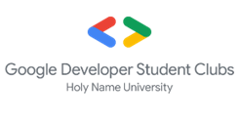

Google Developers

Google Developer Student Clubs Philippines

**Google Developer Student Club - Holy Name University**

**Powered by:**

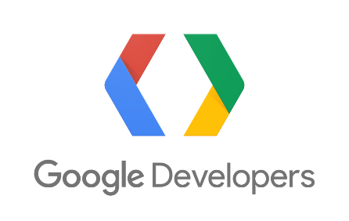

Google Developer Student Clubs is non-profit organization. Nonetheless, when we collect Membership fee and workshop fee not more than a hundred pesos (₱500) for some face-to-face seminars or workshops. We collect those fees for the token of appreciation to the speakers and the participants, and for those events that requires materials.

Proposed by:

**ZACHARY ALBERT LEGARIA**

President/CEO

Approved by:

**MS. NECAH JOY G. MIGRIÑO, LPT**

Student Development Coordinator